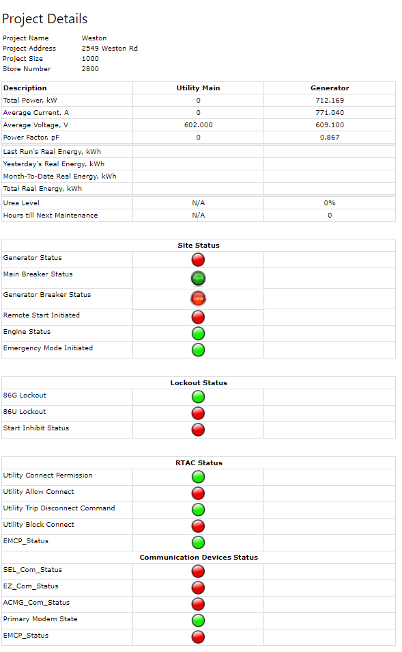

ACMG_COM STATUS Initiated should be Green. Double check logic? Please reverse

EZ COM_STATUS Initiated should be Green. Double check logic? Please reverse

SEL_COM_STATUS Initiated should be Green. Double check logic? Please reverse

EMCP STATUS Initiated should be Green. Double check logic? Please reverse

Emergency Mode Initiated should be Red. Double check logic? Please reverse

Remote Start Initiated should be Green. Double check logic? Please reverse

Generator Status should be Green. Double check logic with dashboard?